**Kth Smallest Element**

**Aim-** Write a C program to find a given kth smallest element in an array of characters

**Problem Statement –** Given a array of characters implement select algorithm to calculate given kth smallest element in the array

**INPUT -**  The number of elements in the array = 11

* Array Elements – E,G,I,L,N,Q,V,F,Q,S,D
* 1] k = 4
* 2] k= 9

**OUTPUT –** Display each step of the process and finally display the kth smallest element

**ALGORITHM –**

**i] Algorithm Select (a,n,k)**

// Selects the kth smallest element in a[1:n] and places it in the kth position of a[1:n] .

//Remaining elements are rearranged such that a[m]<= a[k] ,for i<=m<=k and a[m]>=a[k]

//for k<m<=n

{

low:= 1 ; up :=n+1 ;

a[n+1] ;=∞ ;

repeat {

j := partition (a,low,up) ;

else if (k<j ) then { up := j ; }

else { low := j+1 ;}

until( false ) ; }

**ii] Algorithm Partition(a,m,q)**

//Within a[m],a[m+1]…… a[p-1] the elements are rearranged in such a manner that if

// initially t= a[m] ,then after completion a[q] = t for some q between m and p-1 ;

// a[k] <=t for some m<=k<=q , and a[k] >= t for some q<k<p , q is returned

{ v := a[m] ;

i := m ; j : = p ;

repeat {

repeat { i := i+1 ; }

until (a[i] >=v) ;

repeat { j := j+1 ;

until (a[j] <=v) ;

if (i < j ) {

temp := a[i] ;

a[i] = a[j] ;

a[j] = temp ; }

until (i>=j) ;

a[m] = a[j] ;

a[j] : = v ;

return j ; }

**Space and Time Complexity :**

**I ] Algorithm Select**

**Time Complexity**

1. **Best Case**:
   * In the best case, the pivot divides the array into two equal parts each time.
   * Time Complexity: O(n)
2. **Worst Case**:
   * In the worst case, the pivot is always the smallest or largest element, leading to one partition with n−1n-1n−1 elements.
   * Time Complexity: O(n2)
3. **Average Case**:
   * On average, the pivot divides the array into two unequal parts (e.g., n4\frac{n}{4}4n​ and 3n4\frac{3n}{4}43n​).
   * Time Complexity: O (n logn)

**Space Complexity**

**Algorithm: Select**

1. **Best Case**:
   * Space is required for recursive calls. The depth of the recursion tree is O(log n) for the best case.
   * Space Complexity : O(log n)
2. **Worst Case**:
   * The depth of the recursion tree is O(n) in the worst case (when pivot produces highly unbalanced partitions).
   * Space Complexity: O(n)
3. **Average Case**:
   * On average, the depth of recursion is O(log n).
   * Space Complexity: O(log n)

**II] Algorithm Partition**

**Time Complexity:**

i) **Best Case:**

* **O(n)**
* All elements are scanned and rearranged once relative to the pivot.

ii) **Worst Case:**

* **O(n)**
* Every element is still scanned and rearranged in a single pass regardless of their order.

iii) **Average Case:**

* **O(n)**
* The partitioning process always involves a single scan of all elements in the subarray.

**Space Complexity:**

i) **Best Case:**

* **O(1)**
* Partitioning requires constant auxiliary space for temporary variables.

ii) **Worst Case:**

* **O(1)**
* No additional space is required apart from the input array and temporary variables.

iii) **Average Case:**

* **O(1)**
* Space usage remains constant.

**RECURSION EQUATION –**

**I] Select**

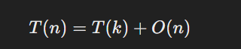

**II] Partition**

The Partition algorithm does not have a recurrence relation because it is not recursive. It is a single-pass operation that rearranges elements relative to a pivot. Its complexity is handled entirely within its single invocation, and no further subproblems are generated. Therefore, no recurrence equation exists for Partition.

**PROGRAM –**

#include <stdio.h>

#include <time.h>

#define MAX 20

char arr[MAX];

void display_array(int n) {

  if (n == 0) {

    printf("Array is empty. Please enter the array first.\n");

    return;  }

  printf("Array elements are: ");

  for (int i = 0; i < n; i++) {

    printf("|%c ", arr[i]);

  }

  printf("|\n");

}

int partition(int low, int high) {

    clock_t start, end;

    double cpu_time_used;

    start = clock();

  int i = low + 1, j = high;

  char pivot = arr[low];

  while (i <= j) {

    while (i <= high && arr[i] <= pivot) i++;

    while (arr[j] > pivot) j--;

    if (i < j) {

      char temp = arr[i];

      arr[i] = arr[j];

      arr[j] = temp;

    }

  }

  arr[low] = arr[j];

  arr[j] = pivot;

  return j;

}

void select(int k, int n) {

  if (k <= 0 || k > n) {

    printf("Invalid value of k. Please enter a value between 1 and %d.\n", n);

    return;

  }

  int l = 0, h = n - 1;

  int j;

  while (l <= h) {

    j = partition(l, h);

    printf ("\n ");

    display_array(n);

    printf (" j = %d and pivot = %c\n", j, arr[j]);

    printf ("\n ");

    if (j == k - 1) {

      printf ("\n ");

      display_array(n);

      printf (" j = %d and pivot = %c\n", j, arr[j]);

      printf ("\n \n");

      printf("%dth smallest element is '%c'\n", k, arr[j]);

      return;

    } else if (j < k - 1) {

      printf ("\n ");

      display_array(n);

      printf (" j = %d and pivot = %c\n", j, arr[j]);

      printf ("\n ");

      l = j + 1;

    } else {

        printf ("\n ");

      display_array(n);

        printf (" j = %d and pivot = %c\n", j, arr[j]);

      printf ("\n ");

      h = j - 1;

    }

  }

}

int main() {

 printf ("*****************************************************");

    printf ("\n Roll number: 23B-CO-010\n");

    printf (" PR Number - 202311390\n");

    printf("*****************************************************\n\n\n");

  int choice;

  int n = 0, k;

   clock_t start, end;

    double cpu_time_used;

  do {

    printf("\n\n--------------- Menu --------\n");

    printf("1. Enter the elements of the array\n");

    printf("2. Find kth smallest element in the list\n");

    printf("3. Display the array\n");

    printf("4. Exit\n");

    printf("Choose your option: ");

    scanf("%d", &choice);

    switch (choice) {

      case 1:

        printf("Enter the number of elements in the array (max %d): ", MAX);

        scanf("%d", &n);

        if (n <= 0 || n > MAX) {

          printf("Invalid number of elements. Please enter a value between 1 and %d.\n", MAX);

          n = 0;

          break;

        }

        printf("Enter the elements of the array (as characters):\n");

        for (int i = 0; i < n; i++) {

          while ((arr[i] = getchar()) == '\n');

        }

        break;

      case 2:   start = clock();

        if (n == 0) {

          printf("Array is empty. Please enter the array first.\n");

          break;

        }

        printf("Enter the value of k: ");

        scanf("%d", &k);

        select(k, n);

         end = clock();

  cpu_time_used = ((double) (end - start)) / CLOCKS_PER_SEC;

  printf("\nTime taken by partition function : %f seconds\n", cpu_time_used);

        break;

      case 3:

        display_array(n);

        break;

      case 4:

        printf("Exiting the program.\n");

        break;

      default:

        printf("Invalid choice. Please choose a valid option.\n");

        break;

    }

  } while (choice != 4);

  return 0;

}

**INPUT -**

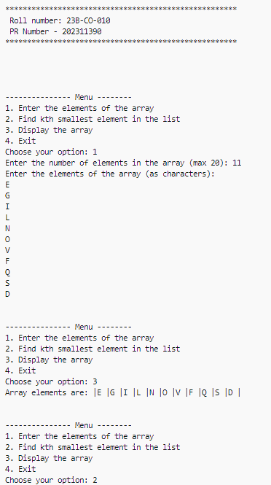

**OUTPUT –**

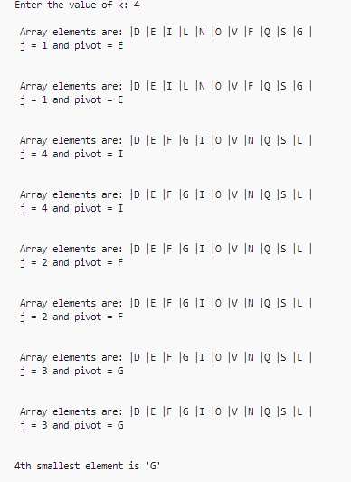 **I] K = 4**

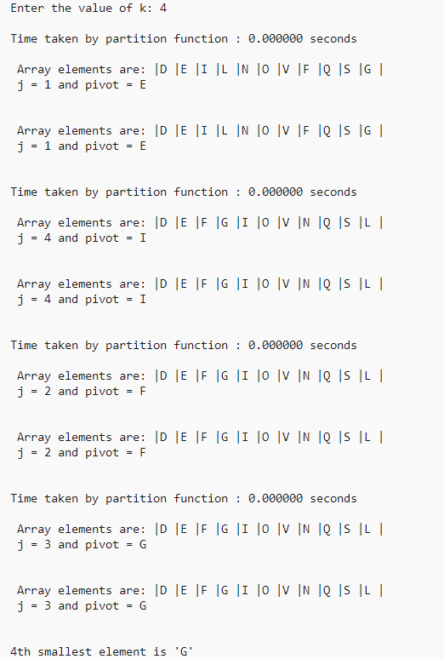

**II] K = 9**

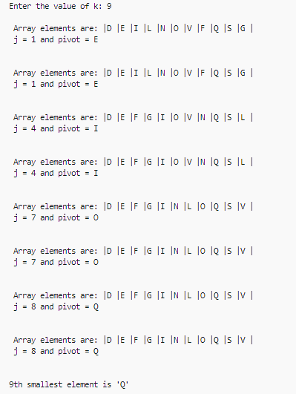

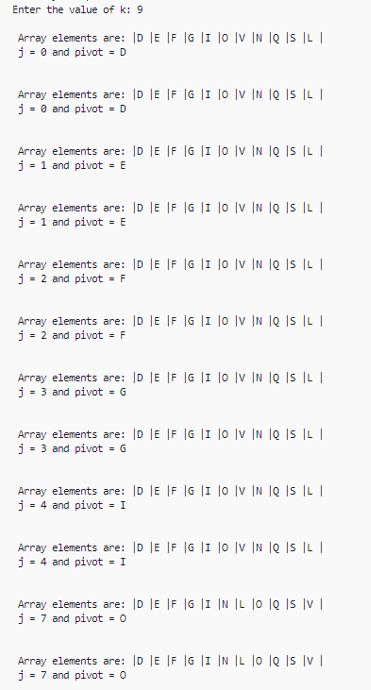



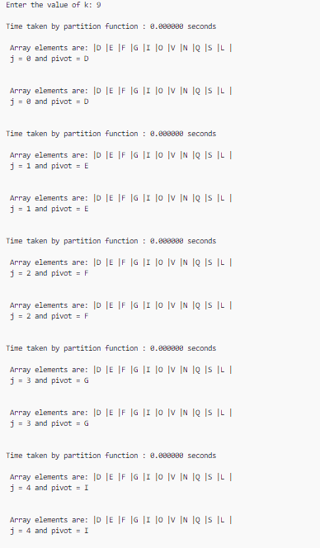

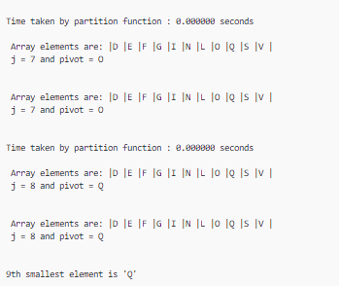



**TIME TAKEN –**

**I] K = 4**

 

**II] K = 9**



**CONCLUSION –** The kth smallest element was calculation sucessfully using select algorithm without any errors .